Week 3 Lab Task
Scanning & Enumeration
NIAI NAVTTC — Certified Ethical Hacker (CEH) Course
⚠ Important: All tasks must be performed only in your isolated virtual lab environment. Never test on real networks or systems without explicit written permission.You can use TryHackMe or Hack the Box rooms for for Scanning and exploitation purpose

Task: Conduct a comprehensive network scan to identify all active hosts and services. Perform vulnerability scanning on identified hosts. Perform active enumeration on a Windows-based network to identify Active Directory users, groups, and systems.

Step 1 — Set Up Your Target VM
▶ Download and Import Metasploitable 2 (or use THM or HTB box)
Go to: sourceforge.net/projects/metasploitable/
Download the Metasploitable 2 zip file and extract it.
In VirtualBox: File → Import Appliance, or just add the .vmdk as a new VM.
Set BOTH Kali and Metasploitable to the same 'Host-Only Adapter' network so they can talk to each other.
Start Metasploitable. Login: msfadmin / msfadmin
Run ifconfig to find its IP address (e.g. 192.168.56.101). Note this IP — you will use it in all commands below.

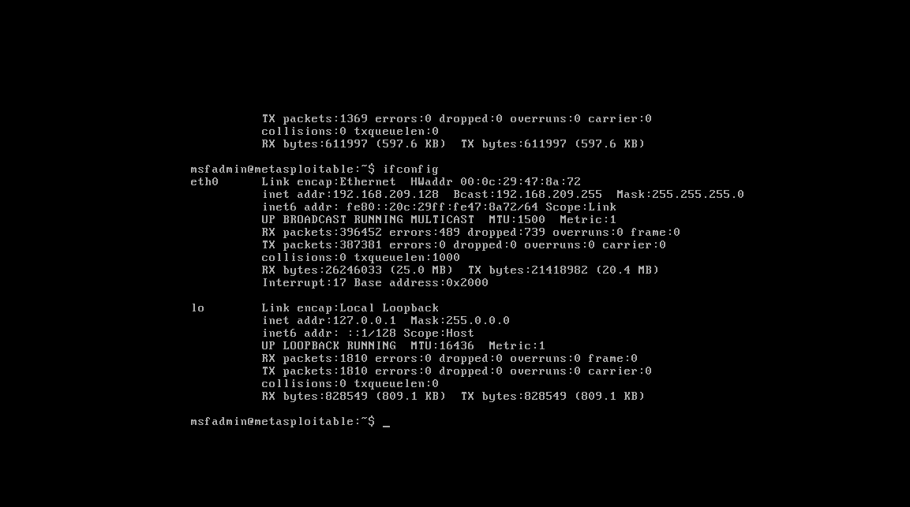

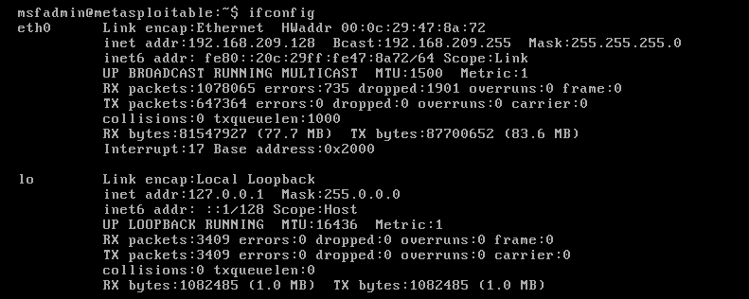

Step 2 — Network Scanning with Nmap
▶ Ping Sweep — Find Live Hosts
nmap -sn 192.168.56.0/24
This lists all devices that are online on your host-only network.

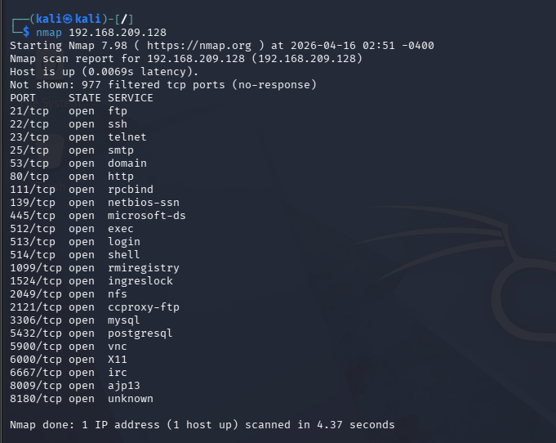

▶ Full Port Scan with Service Detection
nmap -sV -p- 192.168.56.101
-sV detects service versions. -p- scans all 65535 ports.
▶ OS Detection
nmap -O 192.168.56.101
▶ Vulnerability Scan with Nmap Scripts
nmap --script vuln 192.168.56.101
This runs Nmap's built-in vulnerability detection scripts against the target.
Step 3 — Enumeration
▶ Enumerate Windows / Active Directory (if Windows VM is available)
enum4linux -a 192.168.56.101
This tool extracts users, groups, shares, and policies from Windows/Samba targets.
▶ SMB Enumeration
nmap --script smb-enum-users 192.168.56.101
nmap --script smb-enum-shares 192.168.56.101
▶ Additional Enumeration with Nmap Scripts
nmap --script=nbstat 192.168.56.101 # NetBIOS info
nmap --script=snmp-info 192.168.56.101 # SNMP info
nmap --script=dns-brute 192.168.56.101 # DNS brute force
Step 4 — Document Your Findings
▶ Write a Scan Report
Record the following for each host found:
- IP address and hostname
- Open ports and services running
- Operating system detected
- Any vulnerabilities flagged by Nmap
- Any users/shares found during enumeration

1. IP Address & Hostname
- IP Address: [e.g., 192.168.1.10]
- Hostname: [e.g., server.local / example.com]

2. Open Ports & Services
Port | Protocol | Service | Version
22 | TCP | SSH | OpenSSH 8.2
80 | TCP | HTTP | Apache 2.4
443 | TCP | HTTPS | Nginx 1.18
Analysis:
These ports indicate that the host is running web services along with remote administration via SSH.

3. Operating System Detected
- OS: [e.g., Linux (Ubuntu 20.04) / Windows Server 2019]
Analysis:
OS detection suggests the system is likely running [Linux/Windows], which helps in identifying possible vulnerabilities and attack vectors.

4. Vulnerabilities Identified (Nmap)
- [e.g., CVE-2021-41773 – Apache Path Traversal]
- [e.g., Weak SSH configuration detected]
- [e.g., Outdated service version]
Analysis:
The presence of outdated or vulnerable services increases the risk of exploitation. Immediate patching is recommended.

5. Users / Shares Found (Enumeration)
- Users:
  - admin
  - guest
- Shared Resources:

Analysis:
Accessible shares and user accounts may provide attackers with entry points if not properly secured.

Host 2 (Repeat if needed)
1. IP Address & Hostname
- IP Address: [Insert]
- Hostname: [Insert]
2. Open Ports & Services
[List in same table format]
3. Operating System Detected
[Insert]
4. Vulnerabilities Identified
[Insert]
5. Users / Shares Found
[Insert]

⚠️ Overall Findings
- Multiple hosts expose critical services (e.g., SSH, HTTP)
- Some systems are running outdated versions
- Open shares and user accounts may lead to unauthorized access

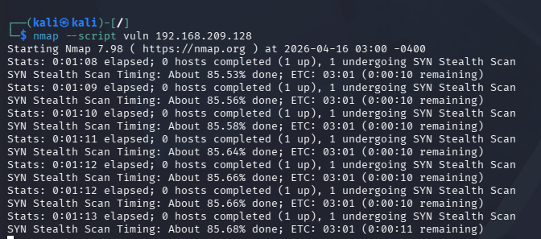

🎯 Goal: A complete scan report listing active hosts, open ports, running services, OS info, and enumerated users/shares — with potential vulnerabilities identified.

